Scenario 6: EFS File System – Multi-AZ Shared Storage Across EC2 Instances
This scenariowe are:
- Creating a security group for EFS
- Creating an EFS file system
- Configuring lifecycle & network settings
- Mounting EFS on two EC2 instances in different AZs
- Writing & reading shared files between both instances
Step 1: Navigate to EC2
- In the top AWS search bar, type ec2.
- Under Services, click EC2.
- Go to the next step.
Step 2: Review Existing EC2 Instances
- In the left navigation pane → click Instances.
- Review the three existing instances.
- Scroll right to see full details.
- Go to next step.
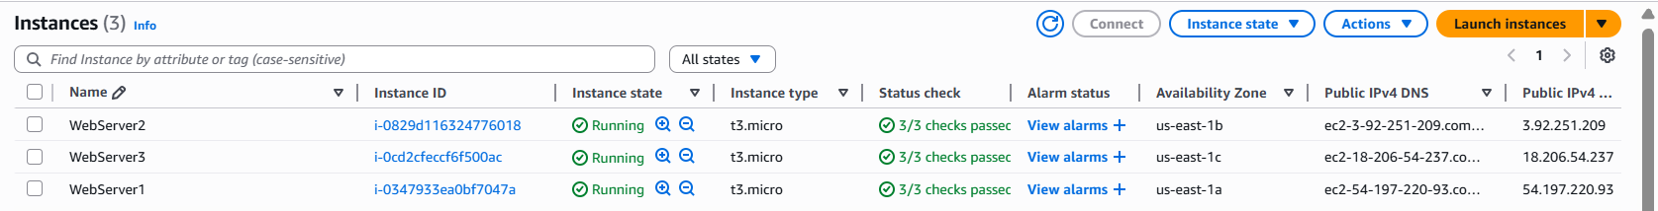

Step 3: identify AZ’s
1. Under Availability Zone, review the AZ for each instance.
2. In the left navigation pane, under Network & Security, click Security Groups.
3. Go to the next step.

Step 4: review existing web server SG
1. In the Security Groups section, review the Web_Server_SG security group.
- The webserver security group is already linked to the web servers.
2. Click Create security group.
3. Go to the next step.
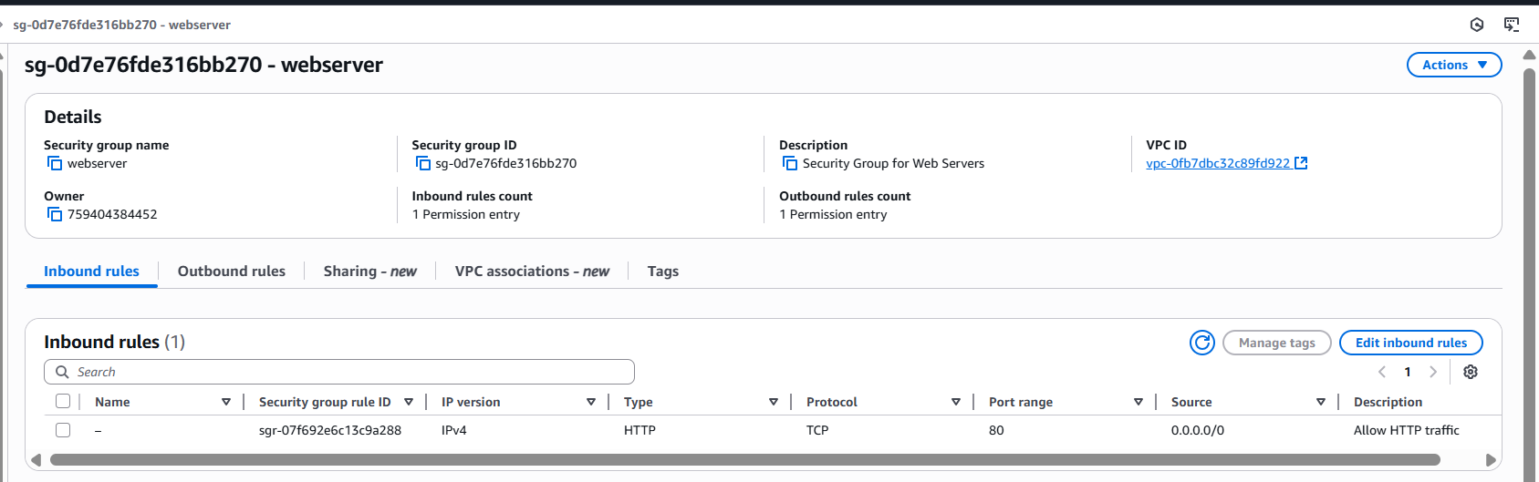
Step 5: create efs SG
1. For Security group name, type: PetModels-EFS-1-SG
2. For Description, type: Restrict access to web servers only.
3. For VPC, on the dropdown list, choose the PetModels VPC.
- You might need to remove the existing VPC by clicking X.
4. In the Inbound rules section, click Add rule.
5. Go to the next step.
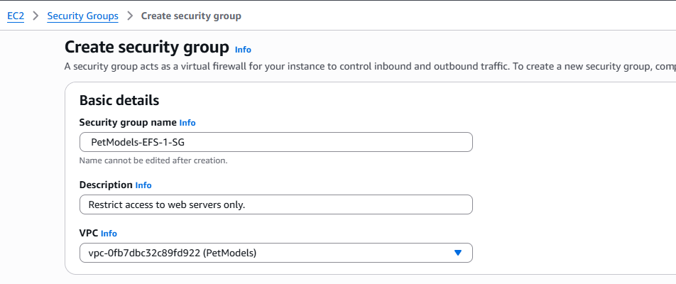
Step 6: allow nfs access
Create inbound rule:
- Type: NFS
- Protocol: TCP
- Port: 2049
- Source: Web_Server_SG (select from dropdown)
Scroll down → click Create security group.
Go to the next step.
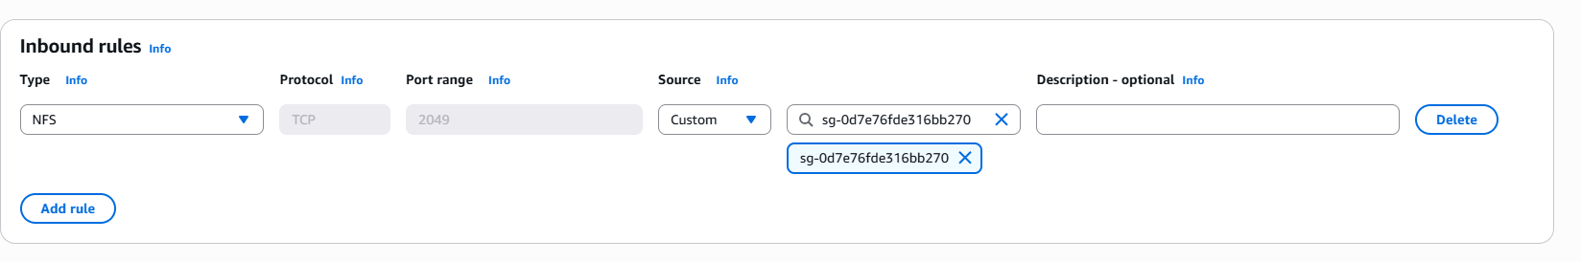
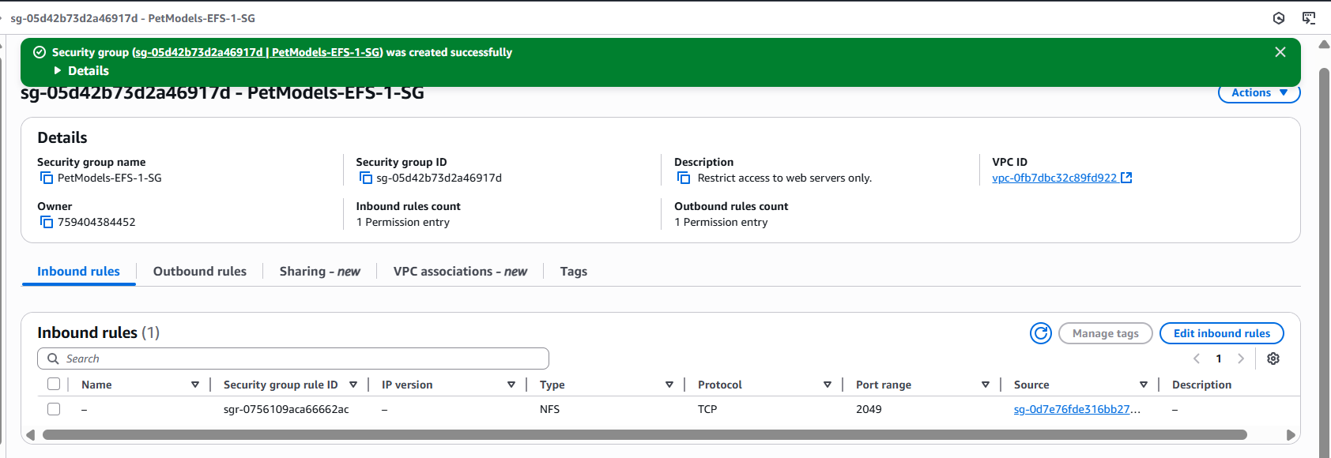
Step 7: Open EFS Console
1. In the top navigation bar search box, type: efs
2. In the search results, under Services, click EFS.
3. Go to the next step.
4. On the Amazon EFS console home page, click Create file system.
5. Go to the next step.
Step 8: EFS setup
1. In the pop-up box, for Name, type: PetModels-EFS-1
2. For VPC, choose the PetModels VPC.
3. Click Customize.
4. Go to the next step.

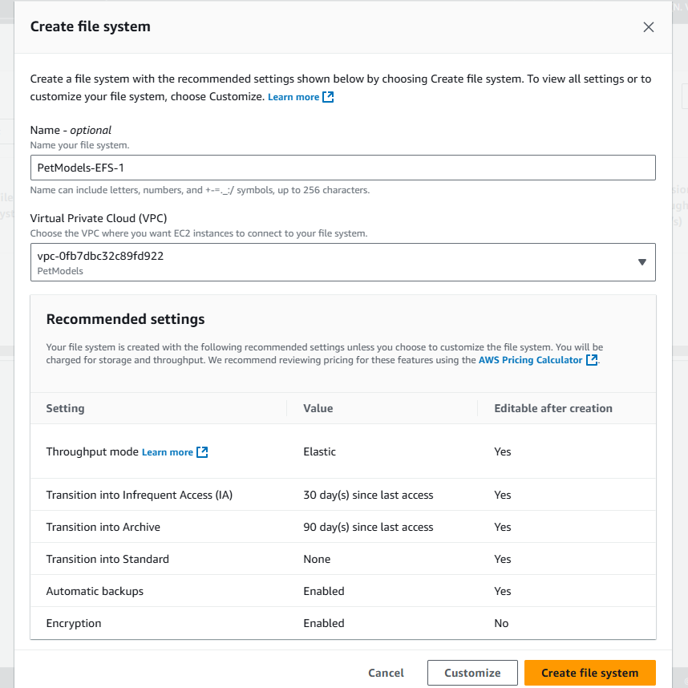

Step 9: file system settings
1. In the File system settings step, under File system type, review the types.
2. disable Enable automatic backups.
3. Go to the next step.
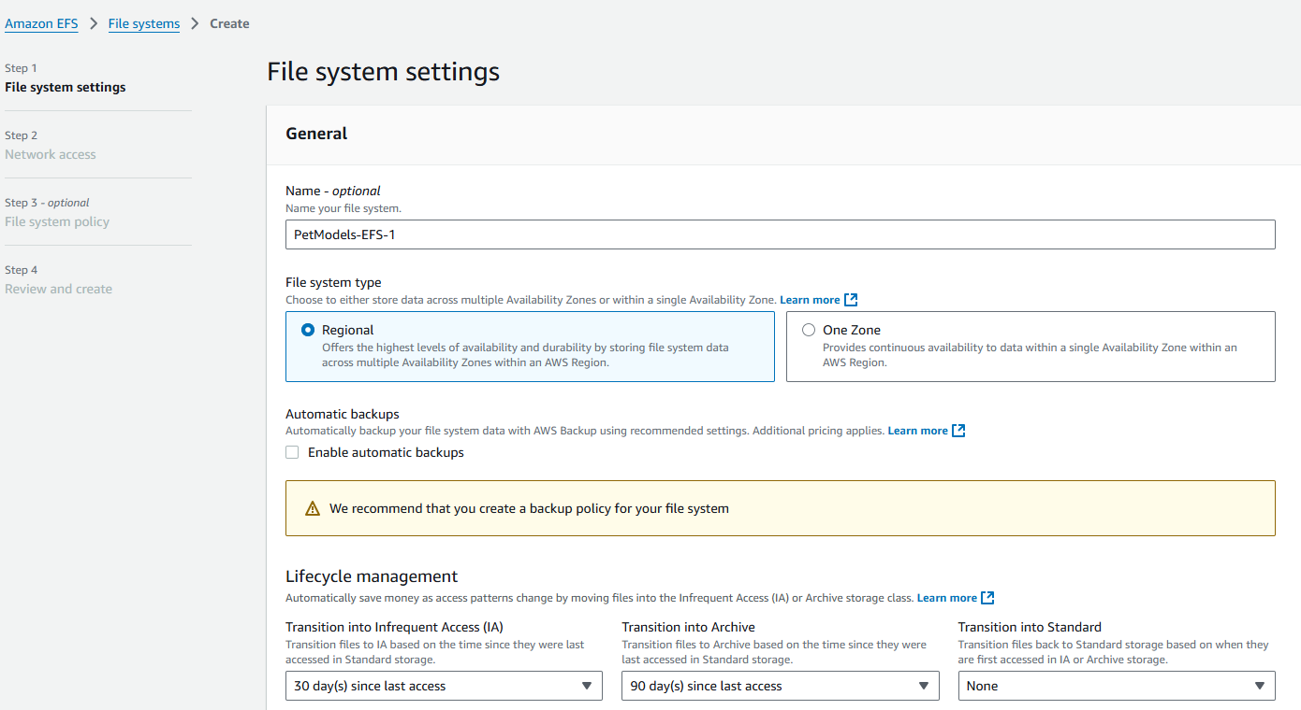
Step 10: lifecycle managemet
1. Under Lifecycle management, for Transition into Infrequent Access (IA), choose None.
- Infrequent Access storage class is designed for storing long-lived, infrequently accessed files in a cost-effective manner.
2. For Transition into Archive, choose None.
- The Archive storage class is designed for data that is accessed very infrequently — only a few times per year or less.
3. For Throughput mode, choose Bursting.
4. Scroll down to the bottom of the page, and then click Next (not shown).
5. Go to the next step
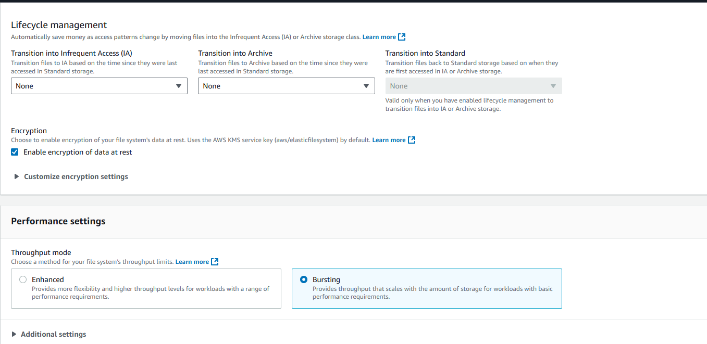
Step 11: configure network access
Remove default mount targets:
- Remove us-east-1c
- Remove us-east-1b
- Under Security groups → us-east-1a, remove the attached SG using X
Go to next step.
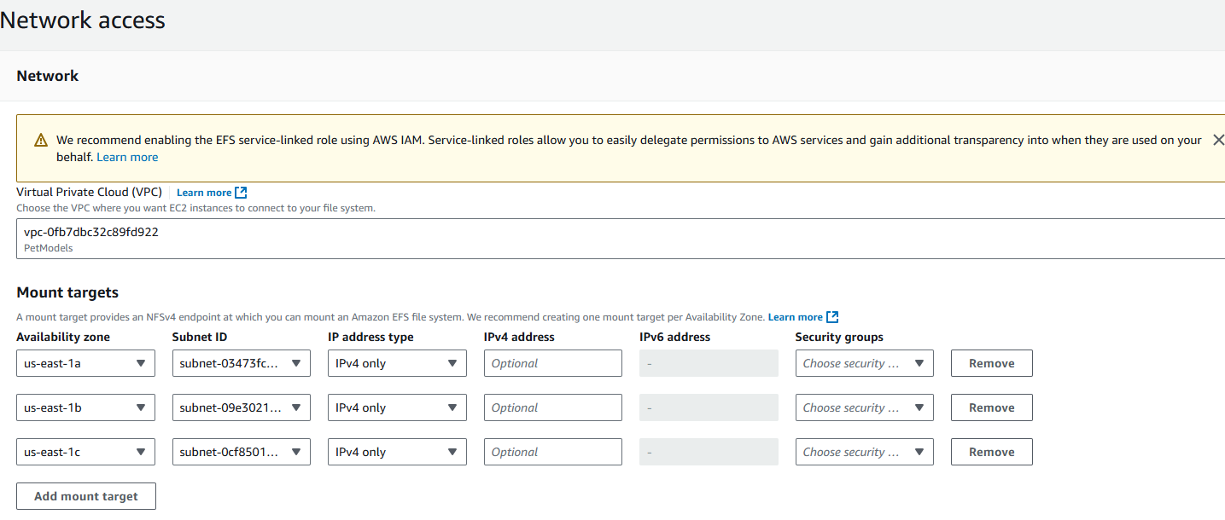
Step 12: Assign EFS Security Group
For AZ us-east-1a:
- Under Security Group → choose PetModels-EFS-1-SG
- Click Next
Go to next step.
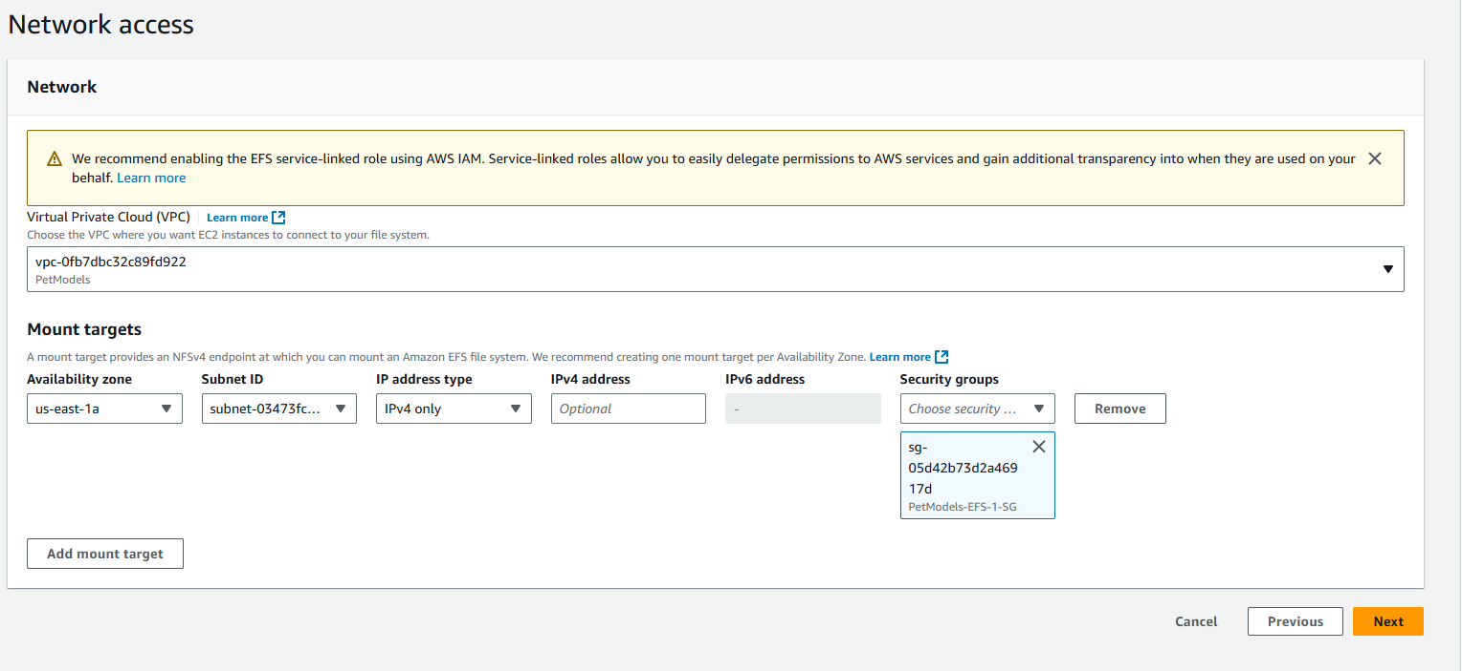
Step 13: file system policy
1. In the File system policy step, click Next.
2. Go to the next step.
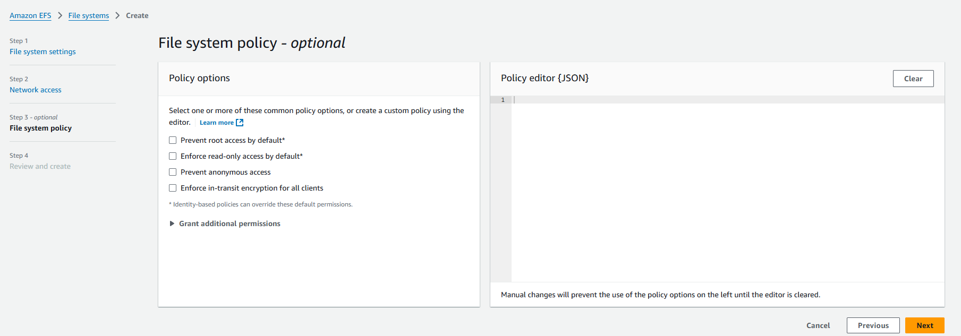
Step 14:
1. In the Review and create step, at the bottom of the page, click Create.
2. Go to the next step.
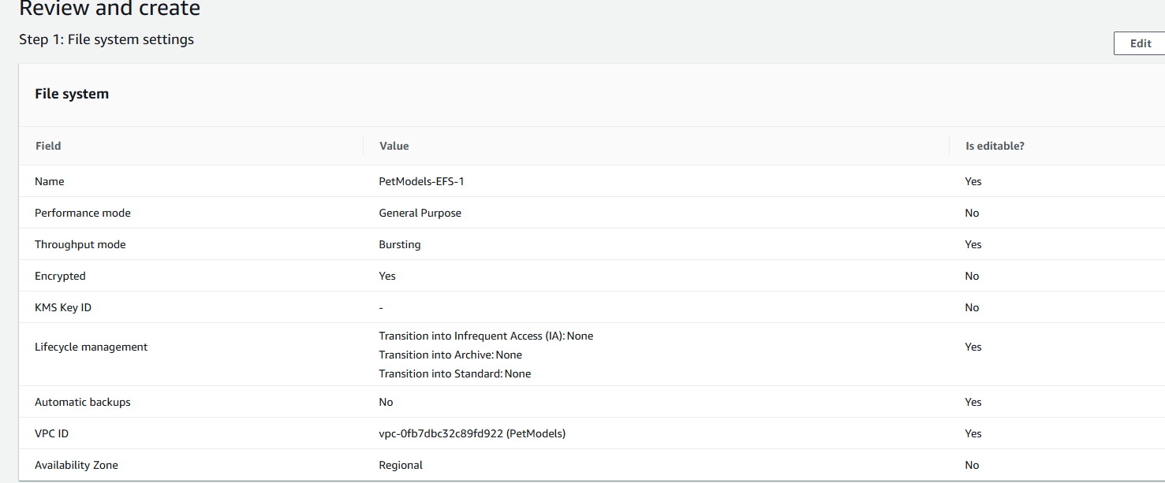
Step 15:
Review
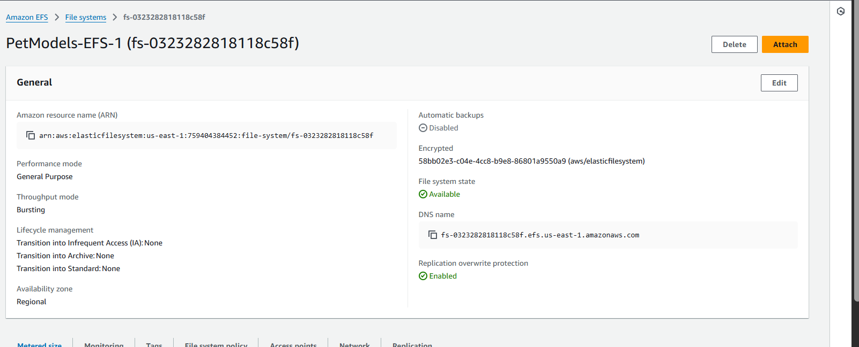
Step 16:
1. Click Attach.
2. Go to the next step.
Step 17: Copy Mount Command
-Keep Mount via DNS (default)
-Under Using EFS mount helper, click copy icon
-Save the command — you will use it on EC2
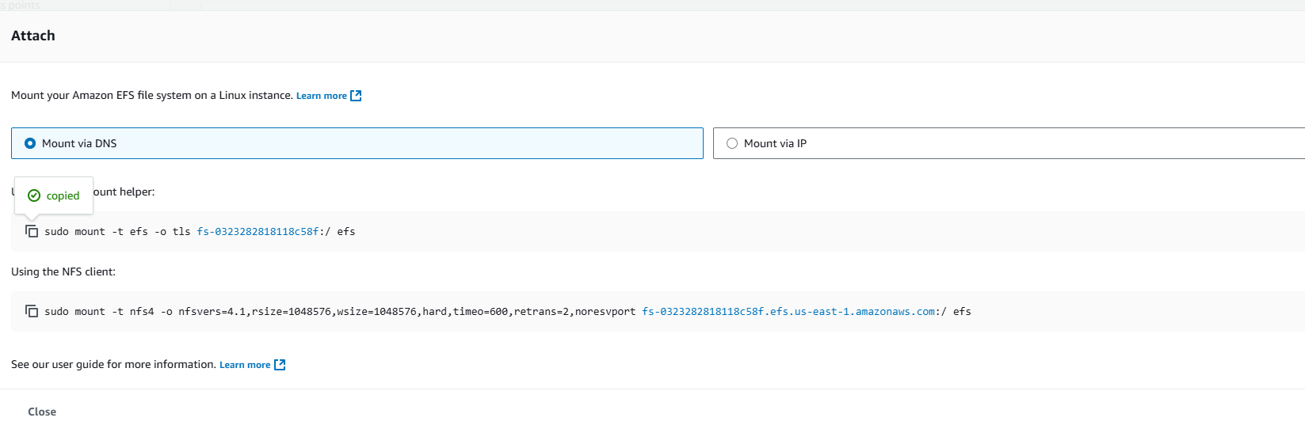
Step 18: Connect to WebServer1
-Navigate back to EC2 Console → Instances
-Select WebServer1
-Click Connect
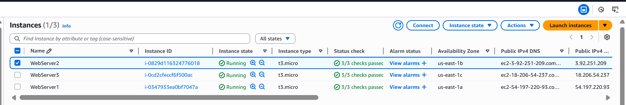
In the terminal
sudo -i
sudo yum install -y amazon-efs-utils
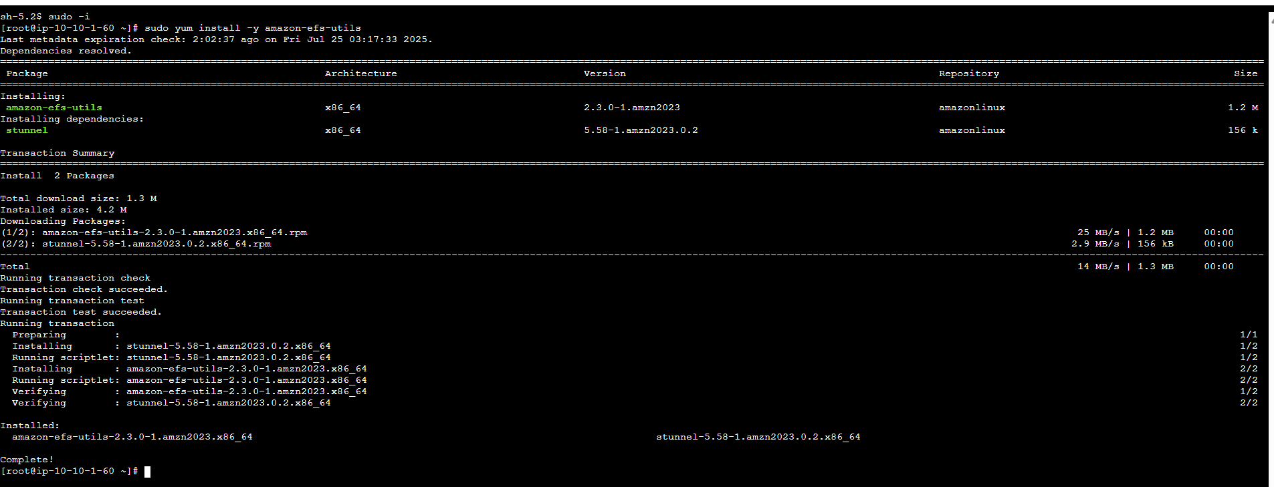
Step 19: Mount EFS on WebServer1
- In this step, you use Linux commands to create a data directory. You then mount the newly created EFS file system to that directory. You create a log file and append information to it. The log file and its contents are visible from other instances that have the same file system mounted.
- Create mount directory:
mkdir data
If permission denied:
cd ~/
mkdir data
- Paste the sudo mount command copied earlier
- Replace the folder path at end with:
Data
- Navigate:
cd data
- Create a log file:
sudo bash -c "cat >> efs-1-setup.log"
- Type:
efs-1 mounted in site A
- Press Ctrl + C
- View file:
cat efs-1-setup.log
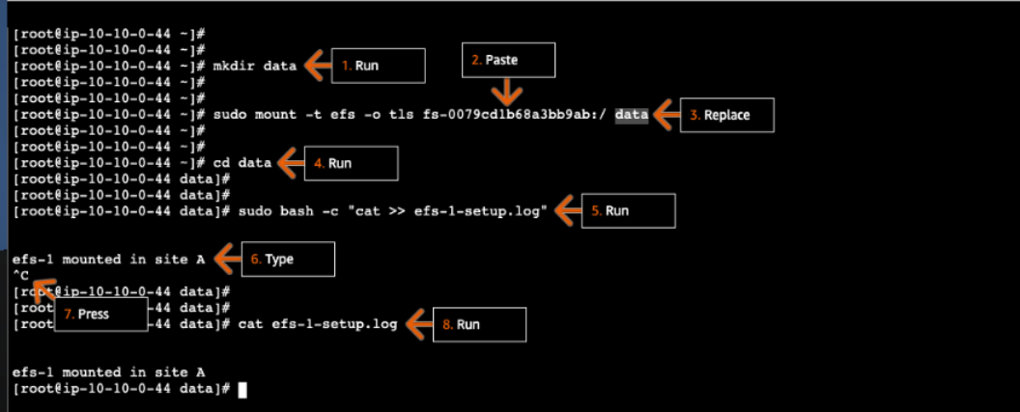

To add another instance of another AZ example AZ-b
Step 1: Add Mount Target
- Go to EFS
- Select your EFS
- Click Network → Manage
- Click Add mount target
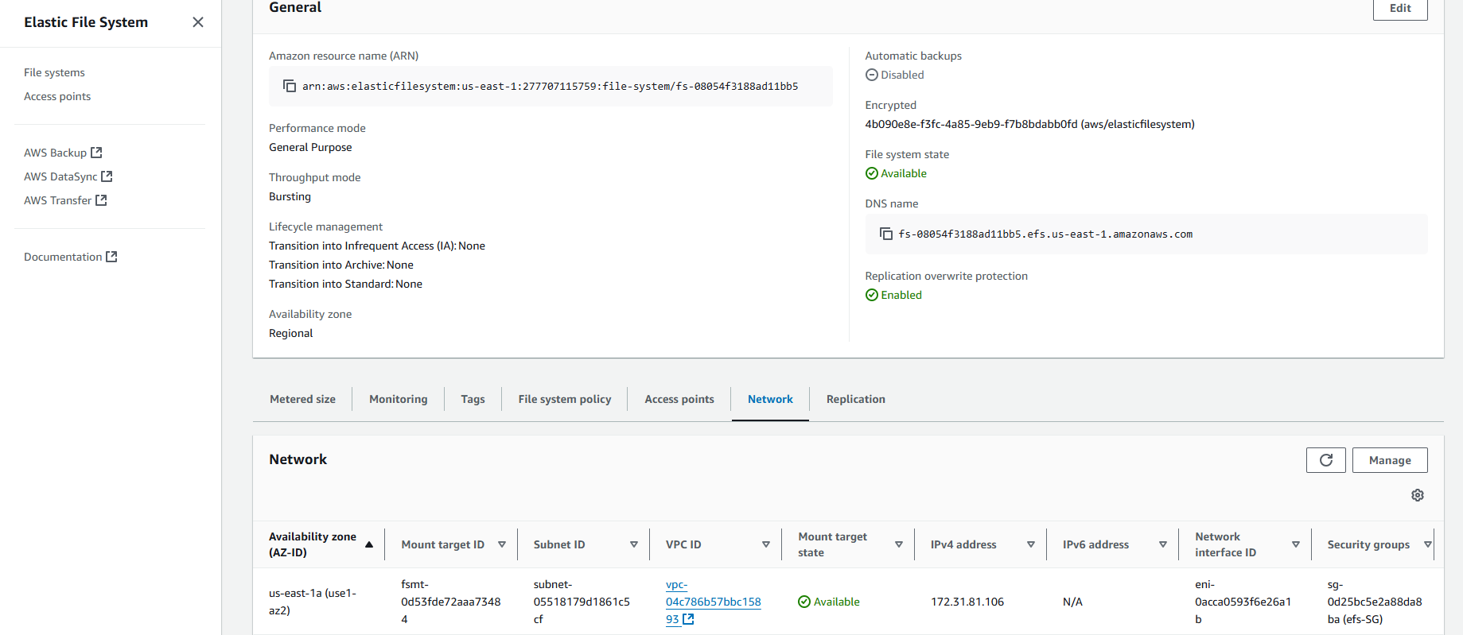
Step 2:
1. Under Mount targets, click Add mount target.
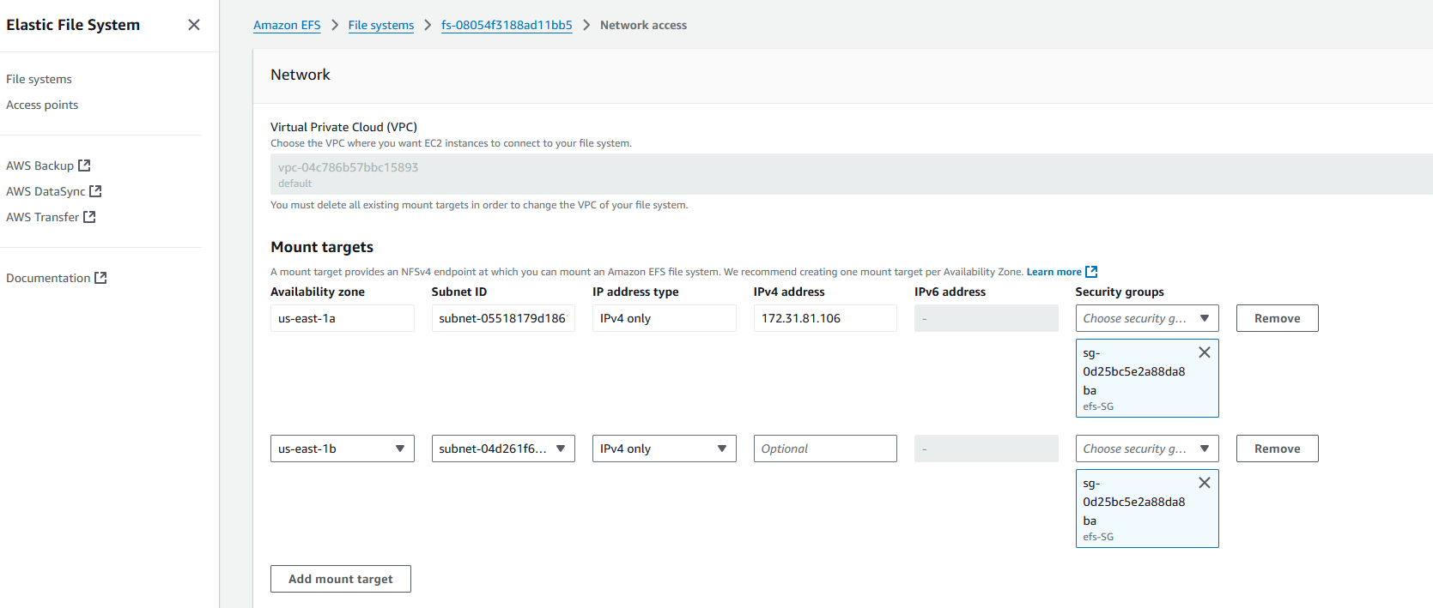
Step 3: connect to ec2 instance (webserver2)
1. In the terminal, run:
sudo -i
2. In the terminal, run:
sudo yum install -y amazon-efs-utils
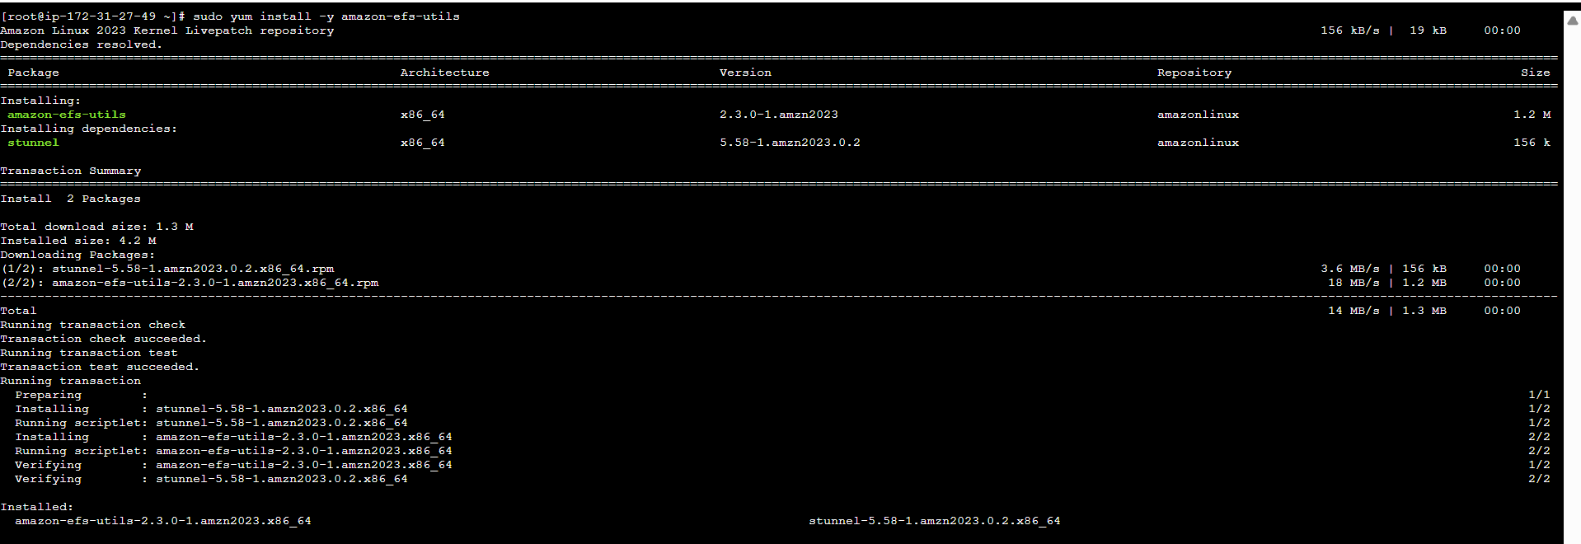
step 4: View Existing Log File
1. To view the log file contents, run:
cat efs-1-setup.log
2. Review the older log entries.
- The changes made in WebServer1 in the efs-1-setup.log file.
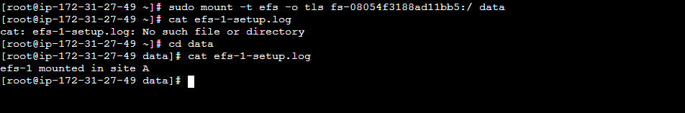
Step 5: Mount EFS on WebServer2
- Create directory:
mkdir data
If permission denied → cd ~/
- Paste the mount command → replace folder with data
- Navigate:
cd data
- Append entry:
sudo bash -c "cat >> efs-1-setup.log"
Type:
efs-1 mounted in site B
Press Ctrl + C
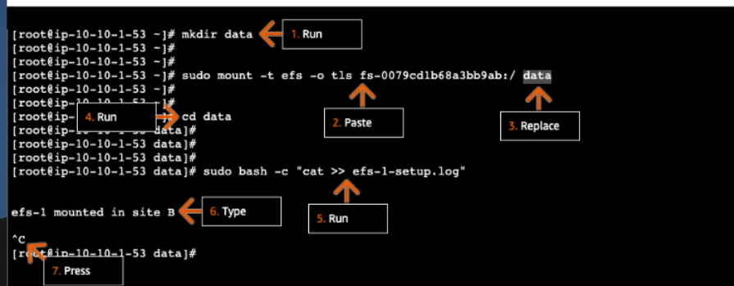
Step 6: Validate Shared Storage
cat efs-1-setup.log
You should see:
efs-1 mounted in site A
efs-1 mounted in site B
Meaning both EC2 instances share the same EFS
